

Adaptive Responses and Risk Management of Extreme Heat

Summary of Good Practices

Prepared by: Nathanial Matthews-Trigg, Robbie Parks, Joy Shumake-Guillemot

Draft 28 September 2017

About this Document

The following document on heat health adaptive responses is comprised of information collected a literature review of global heat health action plans; as reflected in heat health related research; and per discussions with leading experts.

# 

# 

# 

# Introduction: Levels of Protective Heat Health Action

The social ecological model[1] provides a helpful framework for understanding adaptive responses based on four interacting levels of agency to bring about change.

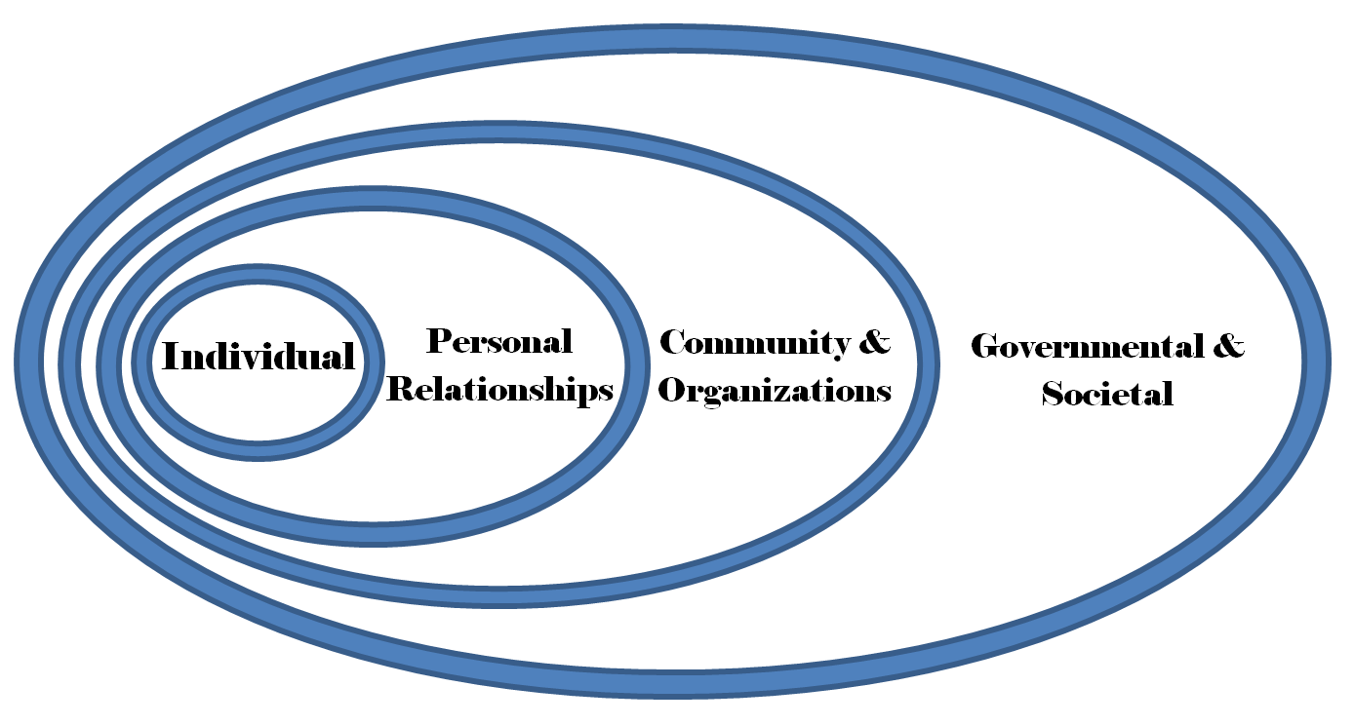

1. The “individual” level is comprised of actions an individual is recommended to take during a heatwave, or overtime to reduce an individual’s future risk of heat stress. These actions are comprised primarily of behavior changes and environmental changes.
2. The “personal relationships” level are adaptive responses which focus on the supportive social interactions that can protect individuals. These actions are centered around changing social interactions between individuals.
3. “Community and organizations” level are an amalgamation of social interactions on an institutional or community level. These can be either informal groups or communities, or can be formal organizations and health care services. The changes at this level are diverse, ranging from supporting employees, to the providing of health care services, and many more.
4. The “Governmental & Societal” level is the broadest unit of adaptive responses, which comprises the aggregate of individuals within a distinct community and the power structures which govern over the community. These changes can have the broadest reach and provide long term adaptations. However, changes at these levels often require the support and advocacy of the other levels.

No level of the adaptive response social ecological model is more important than the other, and all are vital to saving lives in the present and future. The real distinction lies in when and how each level is able to act, who the key decision-makers are, and lastly, the number of people each level effects. It must be noted that the interactions between each level are multidirectional and influence from each level do not flow in one direction.

For example, if the “governmental & societal” level are to offer major heat health subsidies for transformational change, this will most likely require actors from all the other levels to engage collectively. We have included this aspect in the following document as a tantamount adaptive response to the growing threat of extreme heat events.

Each of the following sections are divided into recommended actions to take according to time scale:

1. Directly prior to a heatwave (when a heat wave is forecasted)/during an extreme heat event.
2. During the heat season (typically the summer months - although region specific).
3. Long-term or ongoing - such as throughout the year, or far in advance.

There are more response options in the short term for individuals with fewer options the further away you move from the center of the social ecological model. The governmental and societal levels have more long-term response options available to them, such as heat health legislation and supporting urban planning strategies.

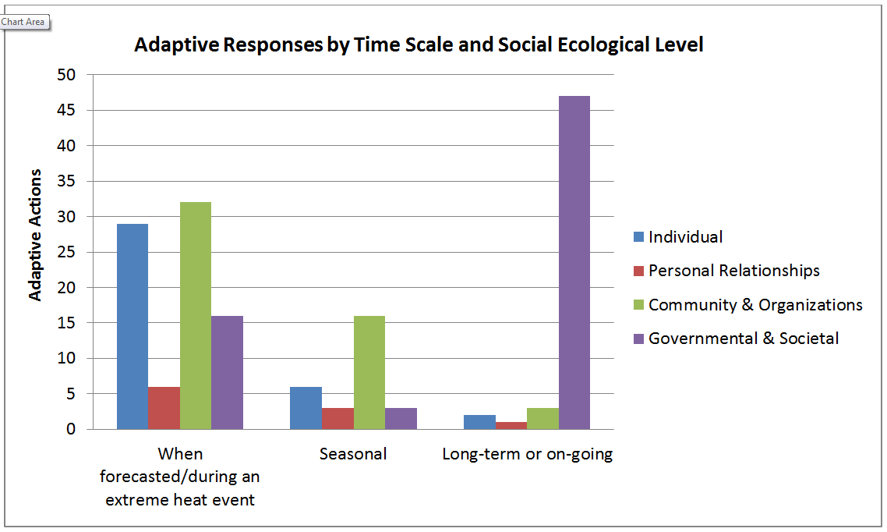

1. Individual Actions

# Individual Actions: Active Hazard

*Directly before or during a heat wave an individual has the most options available to them to stay safe and comfortable during an extreme heat event. We identified 29 unique actions which can be broken into the following four subcategories:*

1. Consume
2. Cooling Activities
3. Preventative
4. Monitor

## Individual Actions: Consume

The human capability to survive extreme heat is largely based on the amount of fluids and foods that are consumed, before, during, and after an extreme heat event. Individuals are recommended to drink plenty of fluids (at least 1.5 to 2 litres per day), and compensate for salt and water loss simultaneously. If a human loses more water through sweat, they are encouraged to drink more fluids. The consumption of foods which have a high water content (such as melons, cucumbers, tomatoes, strawberries, etc.) are a good way to support drinking the required amount of fluids. In addition to fluids, the human body loses salt through sweating, which if not replenished can lead to disability or death. Because of this, consuming a normal amount of salt is a necessary way to stay healthy during an extreme heat event. It is recommended that a person eats several small, light meals throughout the day.

Individual Actions: Consume

1. Drink plenty of fluids - (at least 1.5 to 2 litres a day), and compensate for salt and water loss simultaneously. More fluids may be necessary.
2. Eat fruits and vegetables with high water content (such as melons, cucumbers, tomatoes, strawberries and peaches).
3. Eat several small, light meals a day. Avoid meals that are high in calories, contain fat or high sugar. Food helps replace lost electrolytes.
4. Wash fresh vegetables and fruit before using.
5. Consume cooked food immediately after preparation.
6. Prepared food should be stored in the refrigerator at 8°C and heated to at least 100°C before consumption.

To avoid food borne pathogens, which can thrive under high temperatures and exacerbate the physical dangers of extreme heat, it is recommended that people consume cooked food immediately after preparation, and wash fresh vegetables and fruits before using. Prepared foods should be stored in a refrigerator at 8°C and heated to at least 100°C before consumption. It is recommended that people do not eat large meals, especially if they are high in calories, or sugar - such as ice cream, large servings of meat, or soda. Lastly, alcohol should be avoided as it can lead to dehydration, inhibit temperature regulation, and impair a person’s ability to act safely.

## Individual Actions: Cooling Activities

Individual Actions: Cooling

1. Take frequent cool showers or wipe the head, neck and body with a piece of cloth soaked in cool water to reduce the body temperature
2. Take frequent breaks in a cool environment (AC room, shade, etc.) when exerting energy (such as working or exercising) to hydrate and replenish electrolytes.
3. If you do not have access to a cool environment, try to stay in air conditioned locations such as libraries, large stores, cinemas, etc.
4. Turn off indoor heat sources that are not absolutely necessary
5. Open windows at night when the temperature cools.
6. Use electric fans (below 35C), Mobile evaporative coolers (when low humidity), mobile dehumidifiers (to increase evaporation), or air conditioning. If possible use low-energy technology.
7. Consider leaving town for a cooler area if you're are not prepared for the heat* (<https://www.iom.int/migration-and-climate-change>)
8. Place wet towels over windows (source)

Cooling activities are actions that an individual can take to lower their body temperature and prevent the onset of hyperthermia, or can be used when hyperthermic to prevent further harm.

Individuals engaged in exertional activities should take frequent breaks in cool locations. If it can be avoided, individuals should not exercise during extreme heat. To actively cool down, a person can use evaporative cooling by taking frequent cool showers, or wipe their body with a washcloth soaked in cool water. Fans can be paired with evaporative cooling techniques to increase effectiveness, but fans alone should not be used above 35C.

To prevent an individual’s environment from becoming too hot, they should turn off indoor heat sources that are not absolutely necessary - such preparing foods that do not require the oven, open the windows at night if it's safe to do so, close the shades to prevent direct sunlight, and place wet towels over the windows. If people have appliances such as evaporative coolers (also called swamp coolers), air conditioning, or de-humidifiers, these are often effective ways to cool down a room or house. Electronic appliances can be unreliable, as blackouts are more likely during extreme heat. If the above cooling activities are not enough to keep a person comfortable, moving to a cooler location, such as a designated cooling center, an air conditioned store or library, or a different town or city is recommended.

### **Case Study: India** Seasonal migration from extreme heat

The hill station town of Munnar, Kerala India is 2,000 meters (6,562 ft) to 2,600 meters (8,530 ft) above sea level and rarely gets above 20C during the summer months. The town attracts visitors during the summer months looking to escape the heat and humidity found at lower elevations in Kerala. During British rule, the town of Munnar became the summer capital of British rule in South India due to its cooler climate.

## Individual Actions: Preventative

Individual Actions Preventive Behaviors

1. Plan for heat waves by getting needed outdoor activities done beforehand, such as grocery shopping.
2. Be aware and vigilant of the signs of heat stress and heat stroke - If you, or someone you are with feels dizzy, weak, or anxious, or have an intense thirst and headache, seek medical help as soon as possible, move to a cool place and measure body temperature.
3. If you experience painful cramps, drink oral rehydration solutions containing electrolytes. Medical attention is needed if heat cramps are sustained for more than one hour.

Taking preventative actions when a heatwave is forecasted can improve an individual’s ability comfort and safety during a heatwave. This includes taking actions such as getting needed outdoor activities done before the heatwave - such as grocery shopping, or when the air is cooler in the morning.

During a heatwave, people should be aware and vigilant of the signs of heat stress and heat stroke. If you, or someone you are with feels dizzy, weak, or anxious, or have an intense thirst and headache, seek medical help as soon as possible and move to a cooler location/implement cooling procedures. Other signs to be aware of are painful cramps which require oral rehydration to replace lost electrolytes. If the cramps are sustained for more than an hour, seek medical attention.

## Individual Actions: What to avoid

Individual Action: Avoidance Behaviors

1. Avoid spending extended time on the top floor of buildings where the temperature can be higher.
2. Avoid ultraviolet radiation (direct sunlight)
3. Avoid air pollutants (such as ozone) by refraining from exercising during high pollution times and areas. People with asthma or other respiratory conditions should take extra precautions.
4. Avoid going out of your house during the hottest part of the day
5. Avoid strenuous activities, and if you must, take frequent breaks in cool locations to hydrate and replenish electrolytes.
6. Avoid products containing raw foods, such as homemade mayonnaise (eggs). Care should also be taken when consuming ice-cream and different creams.
7. Avoid alcohol

Avoiding sources of heat, and hot environments is important to staying safe during a heat wave. This includes being aware of indoor temperatures, and avoid spending time in the hottest rooms. The top floor of buildings are often hotter than lower rooms and should be avoided. Try to stay away from direct sunlight and strenuous activities, and avoid leaving your house during the hottest times of the day (which if often later in the day). Pollution, such as ozone or particulate matter, can be worse during extreme heat so taking precautions, especially if you have respiratory issues is vital.

People should avoid eating raw foods made from animal products during extreme heat such as homemade mayonnaise (eggs), as incidences of food poisoning are linked with extreme heat, and can exacerbate dehydration.[1] Similarly, more frequent power outages can compromise the safety of foods. Avoiding alcohol is very important as not only does it exacerbate dehydration, it can inhibit the body’s ability to regulate temperature, and interfere with an individual’s cognitive capacity to make appropriate decisions during extreme heat events.

### **Case Study: India**

In 2010, Gujarat India experienced a record breaking heat wave with an excess mortality of 1,344. The Health Minister Jaynarayan Vyas stated to the media that government hospitals were receiving on average 700 to 800 more patients a day during the heat wave with heat stroke, gastroenteritis and food poisoning.

## Individual Actions: Monitor

Monitoring an individual’s environment, personal health, and staying up to date with weather forecasts and government alerts is an important way to respond appropriately and preventatively to extreme heat events. Monitoring one’s environment consists primarily in monitoring indoor temperatures, and identifying which areas are hottest and which are the coolest. Often upper floors are hottest as heat rises, while basements and lower floors remain cooler.

Individual Behaviors: Monitor

1. Install thermometers to monitor indoor temperatures. Monitor upper floors as well as lower floors.
2. Be aware of elevated risk of forest fires caused by prolonged dry heat.
3. People who are not acclimatized to warm weather (tourists, immigrants, etc.) need to take extra precaution and follow heat health recommendations.
4. People who are chronically ill or vulnerable (such as pregnant or elderly), especially those with cardiovascular, neurological or pulmonary illnesses, need to be especially vigilant. For any changes in your medical/physiological condition, call for help/consult your doctor, and get to a cool location.
5. Be aware that personal protective equipment and personal medication may increase the risk of heat stress.
6. Stay informed of heat alerts (television, internet, etc.)

Being aware of one’s personal health is important, and consists of the following:

1. Being aware of how personal equipment and certain clothing can inhibit the body’s ability to cool itself down.
2. Being aware of how the medications you take may make you prone to heat stress, and contacting your doctor beforehand.
3. Watching for signs of heat stress and taking preventative measures.

It is important to stay up to date on weather forecasts and heat related health hazards such as air pollution or forest fires. This information can often be accessed via the television, internet, or other trustworthy sources of information - such as government alerts.

If a person qualifies as “vulnerable to heat stress”, it is important that they take preventative measures and remain especially vigilant for signs of heat stress, stay up to date on weather alerts, and understand which resources are available and how to access them (such as the location of cooling centers or the number for a heat hotlines). People who are unaccustomed to a climate - such as tourists or recent transplants - should take extra precautions to allow themselves to acclimatize, and follow heat health recommendations.

# Individual Actions: Over time

Actions for individuals to carry out over time, are mostly centered around environmental adaptations to reduce indoor heat through environmental changes. Although some of the listed actions can be done directly before or during an extreme heat event, the ability of an individual to carry out these actions diminishes as services and supplies are often overwhelmed by an increase in demand. It is for this reason that we recommend individuals consider these actions before there is a high demand for such appliances and services.

Environmental cooling actions are the following:

1. Increase shading (installing shutters, exterior curtains, and plants/trees) – especially to southern facing windows
2. Install electric fans (below 35C), Mobile evaporative coolers (low humidity), mobile dehumidifiers, mobile AC. If possible use low-energy or renewable energy cooling technology.
3. Installing thermal isolation materials on roofs and windows (for example double glazing) and increasing roof albedo.  
   Physiological cooling

In addition to environmental adaptations, maintaining a healthy active lifestyle can help an individual acclimatize to hotter temperatures, and has many health co-benefits. Similarly, remaining informed about weather alerts (such as signing up for local weather alerts) can better prepare individuals for extreme weather events, and help people understand which services are available to them in times of need.

Part 2: Personal Relationships

# Personal Relationships Actions: Active Hazard

*When an extreme heat event is forecasted/during an extreme heat event, personal relationship adaptive actions are an important and often underappreciated level of response to extreme heat events. Not only do personal relationships allow for the transfer of information regarding preventative and safe practices, but in times of heat stress another individual is often vital to recognize and seeking help when a person is experiencing dangerous heat stress. This is one of the many reasons that isolated individuals are more vulnerable during extreme heat events.*

**Personal Relationships: Active Hazard**

1. Talk with a doctor about medications you are taking and how these medications may affect you tolerance of heat
2. Take care of infants and children because they are more susceptible to heat-stress. If heat-related symptoms occur, consult a doctor as soon as possible.
3. Pregnant women should travel with company.
4. Check in on neighbours, family, and friends – especially the elderly, those with chronic conditions such as obesity, pulmonary, neurological, or cardiovascular illnesses, or other vulnerable individuals.
5. Have a first-aid kit available and be prepared to use it in case of an emergency.
6. Do not leave pets, children, or elderly in vehicles or in hot locations.
7. Be aware of the signs of heat stress and heat stroke - If you, or someone you are with feels dizzy, weak, or anxious, or have an intense thirst and headache, seek help as possible, move to a cool place and measure your body temperature. If you experience painful cramps, drink oral rehydration solutions containing electrolytes. Medical attention is needed if heat cramps are sustained for more than one hour.

If an individual is taking a medication which can interfere with their ability to stay cool (see list on vulnerabilities chapter), contacting their health care provider is an important step to stay healthy and comfortable during an extreme heat event. Vulnerable individuals should be supported during extreme heat events. This could include pregnant individuals being accompanied when traveling[2], or being checked in on often and regularly by neighbors, friends, family or government/community professionals[3] or volunteers[4]. Staying aware of signs of heat stress and heat stroke, and assisting people who exhibit these signs can save lives.

People and pets which are dependent on others for their wellbeing should be carefully watched for signs of dehydration and heat stress. This includes never leaving children, pets, or elderly people in vehicles or hot locations, and supporting them to carry out the individual environmental and physiological adaptive responses seen in the previous section.

# Personal Relationships Long-term Advance Action

There are several important social adaptive responses that should be carried out over the long-term, such as maintaining the knowledge needed to offer first aid and make sure to have first aid supplies available. Developing social capital, or the social bonds between people in your community, has been shown to be a vital part of building resiliency.[5] This could include getting to know your neighbors and who may be more vulnerable to extreme heat. Strengthening the social bonds between vulnerable members and people who can offer support increases the capacity of a community to deal with extreme weather events.

Personal Relationships: Seasonal Advanced Action

1. Be prepared to offer first aid (e.g. organise a first-aid kit) and take the necessary training to use the first aid kit during an emergency.
2. Community engagement (development of social capital). Get to know your neighbors and who may be more vulnerable to extreme heat.
3. Learn about your local heat health action plan. If there is not one, advocate for one.
4. Civic Engagement

If your country, region, or city has a heat health action plan, learning what is consists of and how you can support or access the services that are offered is important. Sharing this knowledge with others, especially those who require assistance in understanding/accessing the plan, and those who may need the services offered can reduce the

### Case Study: Japan Social Cohesion

iBasho Cafe in Ofunato, Iwate Prefecture, a center for retirees that they run themselves. The center operates as a cafe as well as an organic farm. It provides a place for the elderly to contribute and not be a burden. According to Kiyota, Centers like iBasho show another social model. They motivate the elderly to go out and interact with other sections of society that might need support. Ibasho promotes the value of socially integrating elders and demonstrate the multi-generational social, economic, and environmental benefits of such a community in traditional, developing and modern societies. Ibasho partners with local organizations and communities to design and create socially integrated and sustainable communities that value their elders. We create a place where elders find the opportunities to contribute to their community members of all ages.

### Case Study: At Risk Children

“Each year, children die from heat stroke after being left unattended in motor vehicles. In 2003, the total was 42, up from a national average of 29 for the past 5 years. Previous studies found that on days when ambient temperatures exceeded 86°F, the internal temperatures of the vehicle quickly reached 134 to 154°F”

Part 3: Community/Organizational Action

Community/Organizational level is comprised of a wide variety of social groupings. Community/Organizational groups must have a common goal or purpose, albeit comprised of often diverse individuals - with often different roles (service provider, user, decision maker) and varied expectations and positionalities. Examples of these can range from a factory (workers, manager, boss, CEO), to a community center for the elderly (caregiver, elderly service user).

Community/Organizational level is vital piece of the social ecology of heat stress responses, as

Community/Organizational Action: Active Hazard

**Environmental Change**

1. Creating cooling rooms within facilities.
2. Provide air conditioned rooms, especially for high risk patients/users/members/staff.
3. Turn off indoor heat sources that are not absolutely necessary.
4. Use Electric fans (below 35C), Mobile evaporative coolers (low humidity), mobile dehumidifiers, mobile AC. If possible use low-energy cooling technology.
5. Open windows at night when the temperature cools. Avoid opening windows and blinds during the heat of the day.
6. Consider leaving the area or canceling the event if you do not have the facilities to protect health. This could include taking participants on a field trip, or canceling the scheduled activity. (https://www.iom.int/migration-and-climate-change)

**Behavior Change**

1. Pace tasks so they can be completed with plenty of breaks for hydration and cooling.
2. If upper floors are hotter (see monitoring section), avoid having members/users/patients/staff spend extended time on the top floors.
3. Move patients/vulnerable people to cooler, lower floors.
4. Provide plenty of fluids to users/members/staff/patients (at least 1.5 to 2 litres a day), and compensate for salt and water loss simultaneously.
5. People who are sweating a lot need to replace electrolytes and fluid loss.
6. Taking heat stress into account for organizing large events. Canceling or postponing large outdoor events (sports, festivals, concerts, demonstrations).
7. If possible, allow users/members/staff/patients to take cool showers, or wipe the head, neck, and body with a piece of cloth soaked in cool water to reduce their body temperature.
8. Plan for heat waves by getting needed outdoor or strenuous activities done beforehand.
9. If strenuous activity must still happen, consider halting work during the hottest hours of the day and carrying out activities in the morning or evening when the temperature is cooler.
10. Allow for frequent breaks in a cool location with access to fluids and food.
11. If your location does not have access to appropriate cooling capabilities, consider sending vulnerable users/members/staff/patients home, or transporting them to designated cooling centers, or locations with AC (such as libraries, large stores, cinemas, etc.).
12. Be aware and vigilant of the signs of heat stress and heat stroke - If a user/member/staff/patient feels dizzy, weak, or anxious, or has an intense thirst and headache, seek help as possible, move to a cool place and measure your body temperature. If they experience painful cramps, drink oral rehydration solutions containing electrolytes. Medical attention is needed if heat cramps are sustained for more than one hour.
13. Avoid exposing users/members/patients/staff to ultraviolet radiation, air pollutants such as ozone - refrain from strenuous activities during high pollution times and areas. People with asthma or other respiratory conditions should take extra precautions.
14. Modify patient/user/member/staff diet. Increase consumption of cool foods with high water content such as fruits and vegetables. People should eat several small, light meals a day - during lunch and rest breaks. Avoid meals that are high in calories, contain fat or high sugar. Food helps replace lost electrolytes. Wash fresh vegetables and fruit before using.
15. Consume cooked food immediately after preparation. Prepared food should be stored in the refrigerator at 8°C and heated to at least 100°C before consumption. Avoid products containing raw foods, such as homemade mayonnaise (eggs). Care should also be taken when consuming ice-cream and different creams.
16. If organizing activities that require strenuous exertional activities (such as a sporting event), consider canceling, or postponing the event to a cooler time. Provide ice immersion baths (for physically fit persons) and first aid responders present
17. Adapt pharmacological treatments (consult a doctor about which medications users/members/staff/patients are taking and how the medications may affect their tolerance of heat).
18. Provide users/members/staff/patients frequent breaks, water, and a cool environment (such as shade or a cool room)
19. Encourage staff/employees to wear loose fitting white clothing, wide brimmed hats outside, and other protective/cooling gear. Support them in taking appropriate actions to protect their health. Adjust patient bed and personal clothing.
20. For employees exposed to extreme heat, employers should provide protective clothing and equipment (e.g., water-cooled garments, air-cooled garments, ice-packet vests, wetted overgarments, and heat-reflective aprons or suits).

**Monitor Conditions**

1. Monitor current indoor temperatures (throughout facilities - upper and lower floors).
2. Monitor users/members/staff/patients for signs of dehydration & heat stress (weighing patients)
3. Monitor current weather and weather forecasts.
4. Plan for disruption of electricity
5. Checking in on users/members/staff via home visits or phone calls - monitor need for transportation to cooling centres or ED.

**Social Actions**

1. Communicate the dangers of heat to users/members/staff/patients (multiple languages - may target vulnerable populations)
2. Communicate ways for individuals to protect themselves (see individual column) (multiple languages - may target vulnerable populations)
3. Disseminate information on the dangers of heat, (air pollutants, ultraviolet light - if appropriate), how to stay cool, and services offered, service numbers, or locations (such as number to get transportation to cooling centers, where cooling centers are located, hotline numbers, etc. may do so in multiple languages for immigrants, tourists, etc.)
4. Increase capacity and staffing during heat waves (increase hospital staff, hospital beds, ambulance, etc.)
5. Postpone non-essential surgery
6. Discharge planning (ensuring adequate health and social assistance for high risk patients being discharged)   
   users/membres/staff/patients/employees who have symptoms of heat related illness should NOT be allowed to go home before they stabilize (greatest number of deaths from heatstroke are on the way home).

Community/Organizational Action: *Seasonal Preparedness and Action*

**Environment cooling**

1. Altering the environment to reduce heat (installing AC, exterior curtains, increase roof albedo, building insulation).
2. Take general preventive measures during the whole summer - monitor temperature, keep rooms cool.
3. Creating so-called ‘green zones’ within health and social institutions, by using plants and trees for shading, thus reducing heat-absorption and exposure;

**Physiological cooling**

1. Identify high risk users/members/staff/patients – take specific measures to target vulnerable populations for heat reduction interventions.
2. Take general preventive measures during the whole summer - offer plenty of fluids, provide frequent breaks when its hot, encourage people to take appropriate cooling measures.
3. Encourage user/members/staff/patients to maintain high natural levels of heat acclimatization. This can be achieved by an active lifestyle (fitness) with properly adjusted climatic exposure (see below)
4. Introduce employees to the process of physiological acclimatization - which can be partially achieved within 7 days, and fully within 20 days.
5. This involves scheduling and acclimatization regimes. Even with acclimatization, people still require extra hydration, breaks, and protective measures. (Daily use of AC can inhibit this process - making people more sensitive to heat exposure.*)
6. Conduct preplacement and annual medical evaluations of employees who may be working in high heat environments.
7. Avoid placing users/members/staff/patients on hotter top floors of buildings throughout the summer.

**Monitor**

1. Some situations may require workers to conduct self-monitoring, and a workgroup (i.e., workers, responsible healthcare provider, and safety manager) should be developed to make decisions on self-monitoring options and standard operating procedures.
2. Evaluating work practices continually to reduce exertion and environmental heat stress
3. Worker practice and monitoring programs (e.g. rest, scheduling and acclimatization regimes, bio-physical monitoring and other related measures)

**Social Measures**

1. "Coordinate with health authorities to develop heat health plans, and offer services to those in need."
2. Provide annual training and drills to prepare members/users/staff/patients for extreme heat and how to help others experiencing heat stress.
3. Facilitate social resilience development (promotion of community social capital) by encouraging socialization and cooperation between users/members/staff/patients and the local community.
4. Increase capacity and staffing during heat waves (increase hospital staff, hospital beds, emergency staff, etc.)

Community/Organizational Action: Over time

1. Civic Engagement
2. Develop an iterative heat health action plan that can be reviewed and improved after extreme heat events.
3. Foster working relationships with institutions, organizations, and communities that have shared interests.

Part 4: Governmental & Societal Actions

**TEXT INSERT**

Governmental & Societal Actions: Active Hazard

**Environment cooling**

1. Water roads and parks in the evening

**Services**

1. Outreach to vulnerable populations such as homeless, elderly. Consider evacuations to cooling centers.
2. Provide water in public spaces
3. Set up public cooling centres in locations accessible and central to vulnerable populations - provide transportation to cool centers.
4. Set up a 24hr Hotline - for information on heat responses and heat related emergencies.
5. Extend opening hours of pools and air-conditioned locations  
   Increase staffing for emergency services.

**Legal/Policy Action**

1. Declare Disaster Emergency (if recognized - see below category)
2. Halt utility service suspensions (water, power)
3. Restrictions & Regulations
4. Working regulations prohibit outdoor labour work during hottest times, or specifically vulnerable employees
5. Implement a curfew during the high risk hours of the day
6. Notice on maintenance restrictions: requires transmission and generator operators to postpone planned routine maintenance outages.

**Monitor Conditions**

1. Monitor water quality, air quality, transportation, and infrastructure - issue alerts as required
2. Be prepared for cascading failures (blackouts, transportation issues, etc.)  
   Social Measures
3. Issuing warnings or consider postponing, or cancelling large outdoor events (festivals, demonstrations, concerts, sports)
4. Disseminate up to date weather/forecasts information which includes information regards how people can protect themselves, services available (hotline, transportation to cooling centers, cooling center locations, etc.) – via direct communications (sms, website, emails, emergency broadcasts), or indirect via mass media broadcasting. (This can either be to the general population or targeting specific groups or stakeholders such as employers, fire department, workers, residential care, hospitals, etc.)

Governmental & Societal Actions to take Over time

**TEXT INSERT**

**Environment cooling /urban planning /subsidies for the following**

1. Roofing (roof gardens, cool roofing such as white paint, insulation, etc.)   
   Apply cool paints on outside walls
2. Install energy efficient air conditioning.
3. Increase external shading
4. Increase reflection of heat from the surface (albedo)
5. Shaping the environment (example: allow for better city ventilation_
6. Groundwater coupled cooling
7. Attach radiant barriers
8. Cooling towers
9. Insulation to building structure
10. Earth to air heat exchangers
11. Traditional architectural cooling techniques (windcatchers, stepwells, etc.)
12. Make energy efficient and cool transport systems, work places, and housing
13. Build public fountains, and springs to cool the immediate surroundings
14. Install water fountains in busy public locations
15. Use cool pavements
16. Urban Planning: shading streets, creating water bodies, improving urban ventilation - build and design for future climate
17. Migration* (https://www.iom.int/migration-and-climate-change) - move communities away from EH areas

**Management**

1. Energy management during peak hours (foresee and reduce risk of blackouts)
2. Develop clear guidelines for heat wave responses (chain of command) - coordinate with identified stakeholders
3. Mandate and review temperature related health and safety regulations in the workplace

**Services**

1. Building partnerships across agencies and sectors - to provide needed services
2. Reduce social vulnerabilities - provide services or funding for services such as poverty reduction, drug treatment, reducing social isolation.
3. Develop information systems on the urban climate - provide information stakeholders, policy makers and the general public.
4. Develop a HHAP which includes a HHWS; a comprehensive communications plan. Disseminate the plan to stakeholders.

**Legal/Policy**

1. Solar panel driven air conditioning systems should be assessed as part of a national policy.
2. Encourage individual adaptive action (such as subsidies for cooling technologies and reducing energy consumption)
3. Legally recognize a heatwave as ‘disaster emergencies’
4. Land-use changes
5. Review national building codes for residential buildings (taking extreme conditions into consideration)
6. Institute urban planning policies which encourage and support shading streets, creating water bodies, improving urban ventilation - build and design for future climate
7. Mitigation of climate change (e.g. energy efficiency of building structures, including heating methods in winter)
8. Compensating for productivity losses due to heat via expanding the use of information and communications technologies or modernized agricultural technologies.

**Restrictions and Regulations**

1. Restrict and regulate t the number of motor vehicles/increase public transportation on hot days
2. Restrict living on top floors or improve roof insulation
3. For occupational health and productivity: strengthening labour institutions, guidelines, regulations, protection programs, and policies.

**Transformational**

1. Reduce the number of motor vehicles/increase public transportation
2. Fiscal and regulatory intervention to speed structural economic shift towards industries involving non-outdoor work (especially in the service and industrial sectors)

**Monitor**

1. Tracking of vulnerable individuals
2. Identify areas at risk of urban heat island effects
3. Develop and implement a heat health or multi-hazard early warning system.
4. Provide heat health information dissemination technology

**Social Measures - often very culturally specific**

1. Cell phone app buddy system for elderly (HK)
2. Encourage a buddy system (Philly), The city identifies and trains "block captains" to assist neighbours and work with local authorities.
3. Disseminate information on the dangers of heat and how individuals can protect themselves. This can be done through media, pamphlets, or technology.
4. Multidisciplinary education of architects and urban planners (include summertime comfort in planning)
5. Facilitate social capital building - community heat wave drills.

1. IPCC: <https://www.ipcc.ch/publications_and_data/ar4/wg2/en/ch8s8-2-4.html>
2. Thailand HHAP
3. Nurses/health staff - Philadelphia
4. Block captains - Philadelphia
5. http://journals.sagepub.com.offcampus.lib.washington.edu/doi/pdf/10.1177/0002764214550299